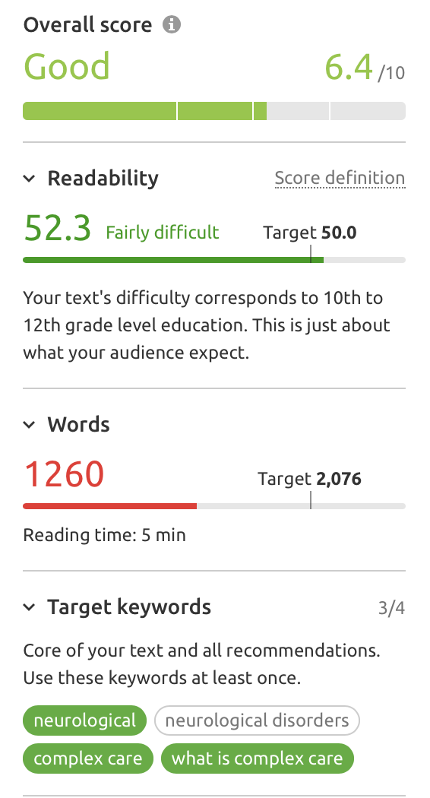 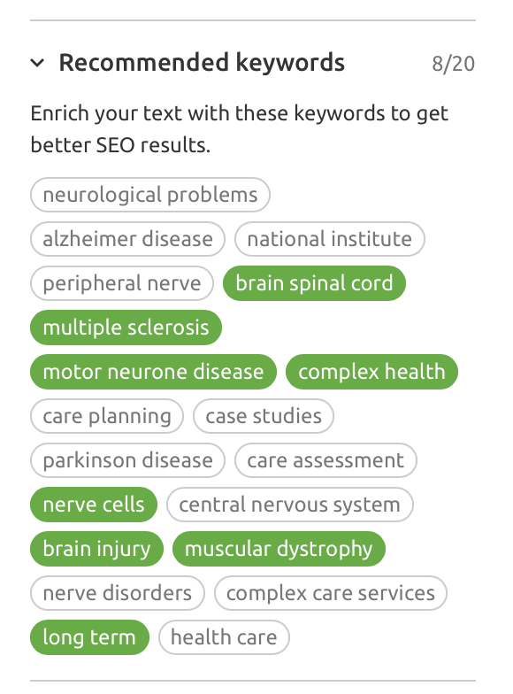

***Note Marie.. You are missing one of you target keywords in your article “neurological disorders”***

*Neurological (27,100 – 59%)*

*Neurological disorders (5,400 – 79%)*

*Complex Care (390 – 74%)*

*What is complex care (140 – 92%)*

**COMPLEX CARE**

Complex Care is exactly that – complex! It can include a huge range of conditions, including neurological conditions, respiratory conditions, life-limiting illnesses and life-changing injuries.

When you have one of these conditions, living what is deemed to be a ‘normal’ life may feel out of your reach. But this should not be the case. We have the skills to be able to support you in the comfort of your own home to achieve your aspirations and goals, living an active and fulfilling life.

Our compassionate and experienced nurse-led team are specially trained in all aspects of complex care including medication administration, ventilator use, tracheostomy care, PEG-gastronomy and continence care (including catheter, bowel and stoma care). This means we can provide a team trained to meet your needs – no matter how complex.

We understand that no two people are the same, so we ensure that each of our care packages are as unique as the people we support. Our aim is to ensure every person can live as active, fulfilling and independent life as possible regardless of their complex needs. We will ensure they have every opportunity for choice over their care and their day to day lives.

As a result of this additional support, you can enjoy spending time as a family, safe in the knowledge that we have your physical, medical and emotional needs in hand. We constantly review the care and support we are providing to ensure it evolves as your needs change, ensuring it is always as relevant and effective as possible. If something isn’t working, we will find another way to do it.

If required, we can support the transition home from another location, such as hospital or nursing home, to ensure as smooth a transition as possible. By providing specialist care at home we can then help to avoid unnecessary, and sometimes upsetting, subsequent hospital admissions.

We understand that a complex diagnosis can also have a huge impact on the family of the people living with the condition, so we will alongside you, your family/carers and existing healthcare professionals, ensuring we respect your needs and wishes at all times.

We are fully regulated by the Care Quality Commission, giving you peace of mind that your care will be of the highest quality by staff that are selected and trained specifically for your needs. If you would like to discuss your future care with us, we will be only too happy to help you explore how to live the life you want to.

**WHAT IS COMPLEX CARE**

Complex care is a holistic service that provides specialist care and support to people with a wide range of physical and mental health needs. It can include providing help with personal care and physical needs as well as offering emotional support and companionship to someone in their own home.

Complex Care is delivered with input not only from the person we are supporting, but also their family and other healthcare professionals such as GPs, specialists and Clinical Commissioning Groups (CCGs).

Complex Care at home means that someone with very complex health requirements can remain living at home and retain their independence.

**COMPLEX CARE CONDITIONS**

Some of the most common complex conditions include that could require complex care at home are:

**Multiple Sclerosis**

Multiple Sclerosis is a the most common disabling neurological disease in the UK with over 100,000 sufferers. Most people are diagnosed in their 30s, 40s and 50s, but symptoms may appear as early as your early 20s or even your teenage years in some cases. The disease affects three times more women than men. It is a life-long condition that affects the brain, spinal cord, vision, balance and other basic functions. Some people may have mild symptoms that are easy to manage, while for others, the symptoms may be more severe, requiring additional support with routine tasks.

**Motor Neurone Disease**

Motor Neurone Disease is a rapidly-progressive disease that affects the nerves in the brain and spinal cord. It weakens muscles to the point that they will stop working. Symptoms include difficulty when walking, talking, gripping, breathing and swallowing. It can also cause difficulty with cognitive functions such as decision making and language. As the disease progresses you will need increasing support with everyday tasks and personal care.

**Cerebral Palsy**

Cerebral Palsy is a term used for a group of life-long conditions affecting movement and co-ordination. They are caused by damage caused to the brain during, or shortly after, birth. Symptoms usually start to show when a child reaches two or three years old. These symptoms can include delayed development, weak limbs, uncontrolled movements, walking on top toes, vision problems or learning difficulties. Every person affected is so to a different extreme.

**Muscular Dystrophies**

Muscular Dystrophy is a term that covers around 60 rare muscle wasting conditions. In the UK about 1 in every 1,000 people has been diagnosed with a muscle wasting condition. Muscular Dystrophies are genetic conditions which weaken the muscles over time. Symptoms usually start with a specific group of muscles being affected, but over time it affects more muscles. Some types of Muscular Dystrophy affect the heart, or the muscles used for breathing. At this stage the condition becomes life-threatening.

**Huntington’s Disease**

Huntington’s Disease is an inherited disease caused by a faulty gene. It results in damage to the nerve cells in the brain and gets progressively worse. It can affect functions such as movement, awareness, judgement, perception, balance, vision and behaviour. In the early stages of the disease symptoms including mood swings and lack of concentration can be over-looked, but as the disease progresses, they will gradually get more pronounced. The disease usually gets worse over a 10-15-year period from when it is diagnosed.

**Epilepsy**

Epilepsy is a condition that affects the brain and causes seizures. Epilepsy can start at any age, but the most common ages is either in childhood on in those over the age of 60. It is often a life-long condition but in some cases can get less severe over time or with medication. There are many types of seizures including collapsing, uncontrollable shaking, passing out, staring into space, or experiencing strange sensations. If seizures are very severe in duration or frequency, additional support may be required when carrying out personal care and day to day tasks.

**Post Trauma/Acquired brain injury**

Some people suffer a head injury during an accident such as a collision or fall, or after a seizure or other medical occurrence. These are called post trauma/acquired brain injuries. Resulting symptoms can be wide-ranging and to differing severities. They can include seizures, memory problems, change in behaviour, full or partial paralysis, poor co-ordination, difficulty walking or controlling limbs, difficulties eating/drinking, hearing or vision loss and confusion. In some of these cases the symptoms may disappear over time, but in others they are life-long, requiring long term care and support.

**Strokes**

Although you could have a stroke at any age, your risk of having a stroke doubles each decade after the age of 55. While some people who suffer a stroke go on to make a full recovery, others can suffer from widespread and long-lasting problems which require additional care and support. Lasting symptoms can include memory loss, confusion, loss of feeling or movement in one side of the body, depression, anxiety, panic attacks, difficulties talking or praxis – the ability to carry out skilled activities such as making a cop of tea or getting dressed.